**Build APIs with Node.js and Express.js for Shoppyglobe E-commerce**

**Node.js server is running on port 5000 and has successfully connected to MongoDB**

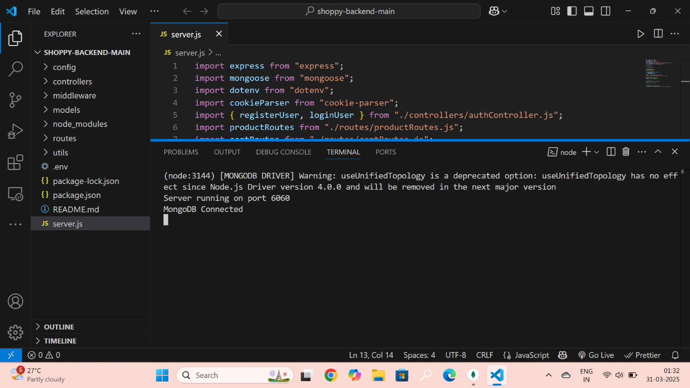

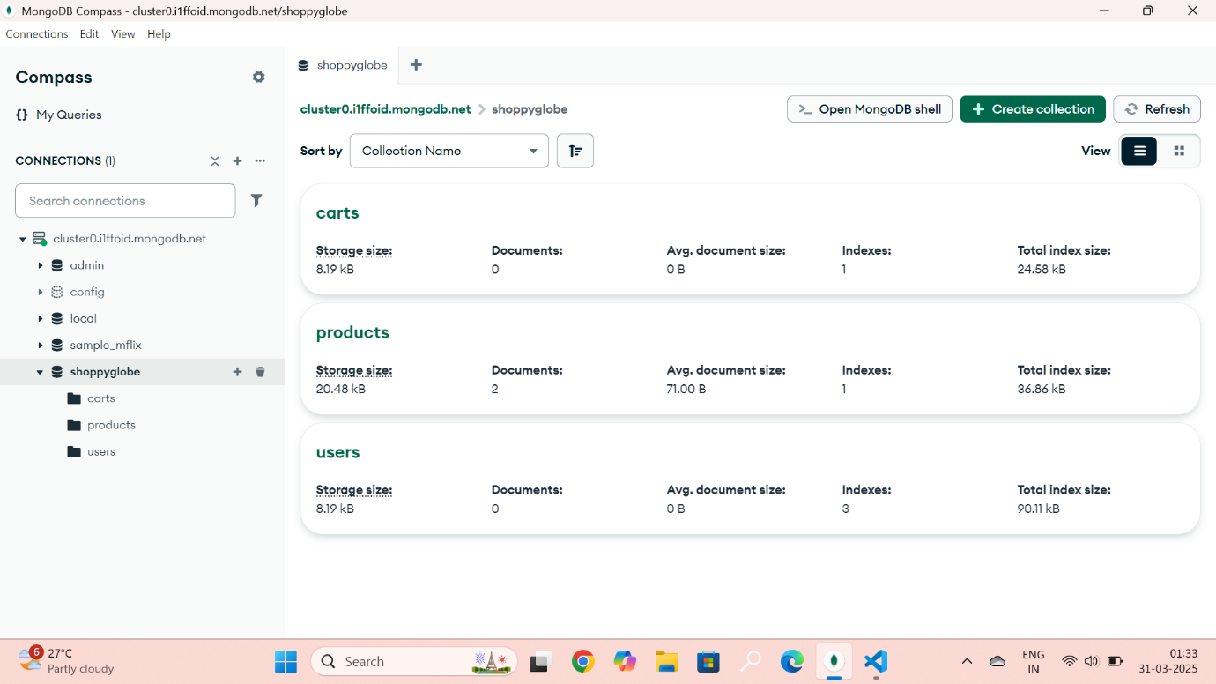

**Register User :**

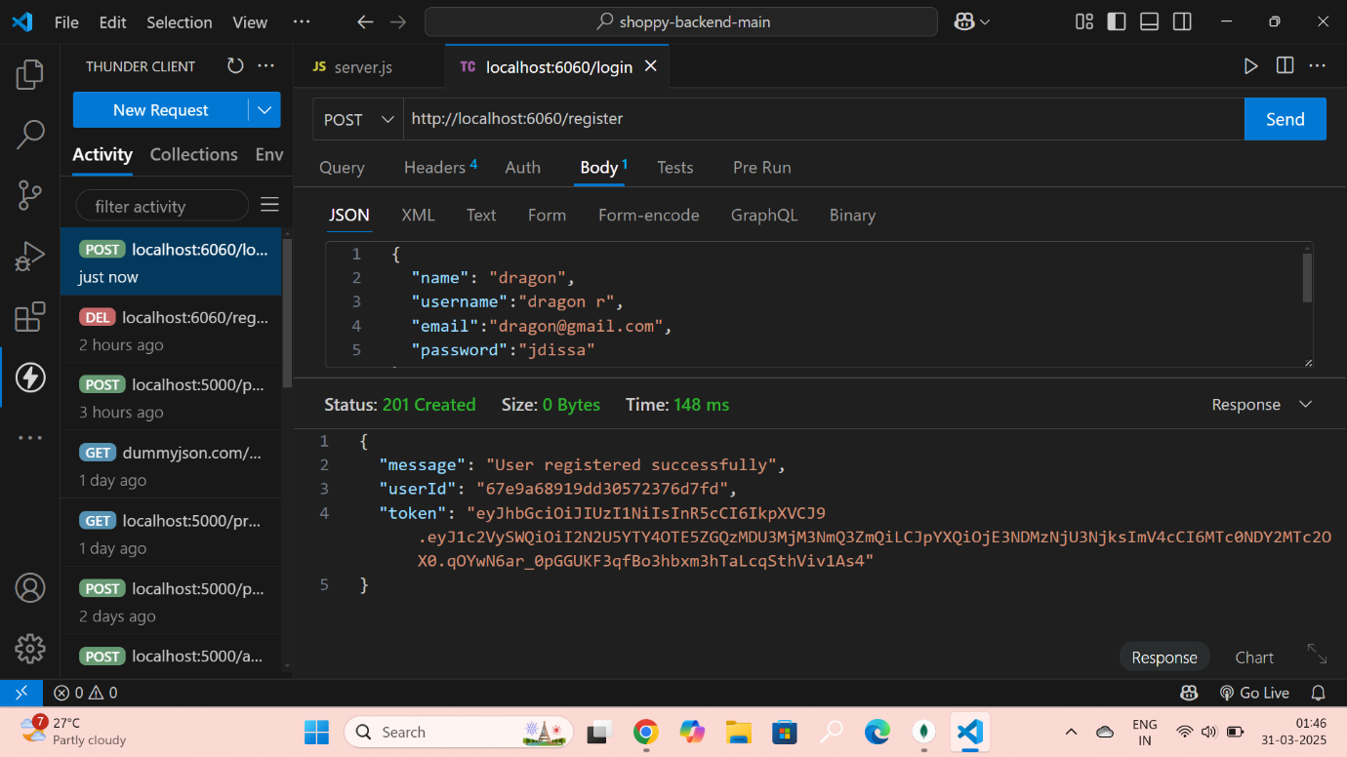

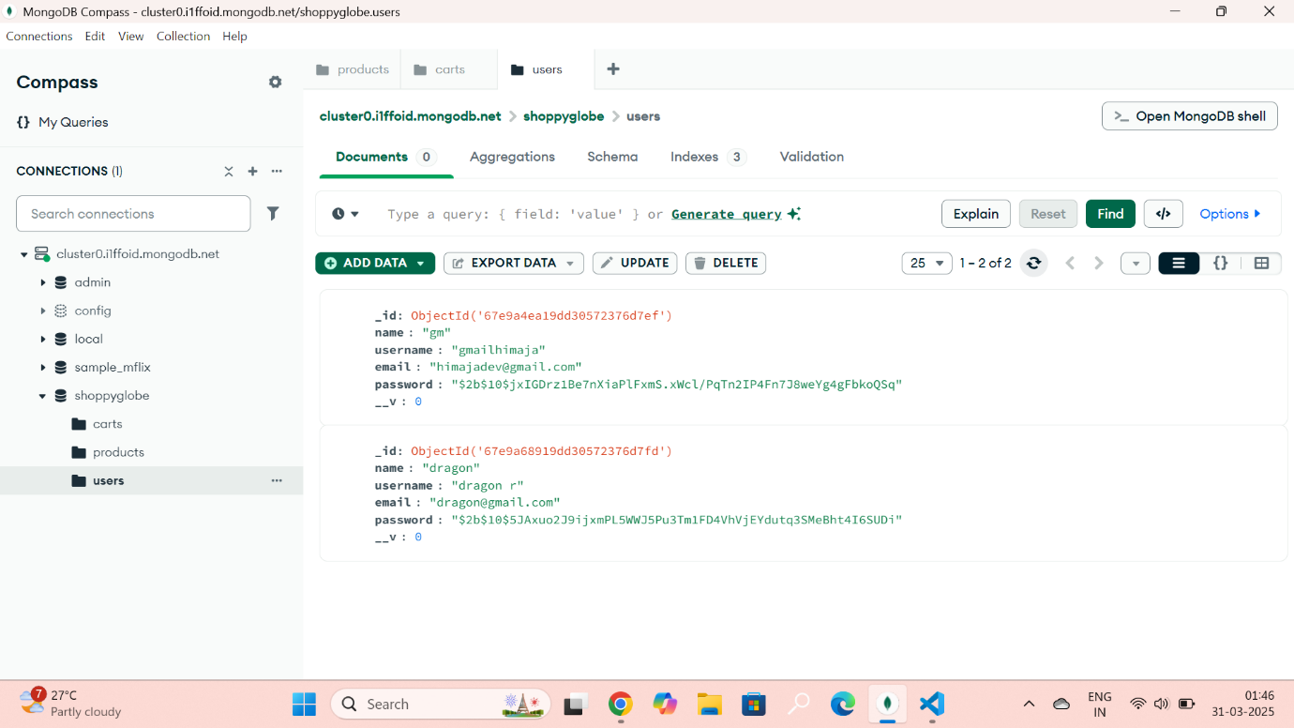

**1. GET /Products – Retrieves a list of all users from the MongoDB database.** 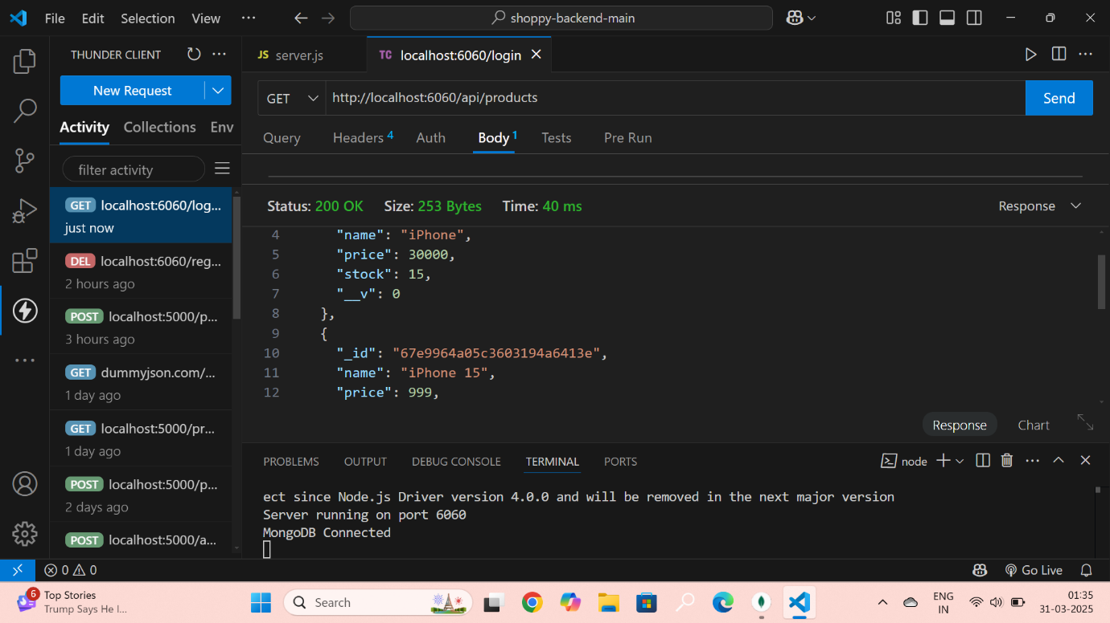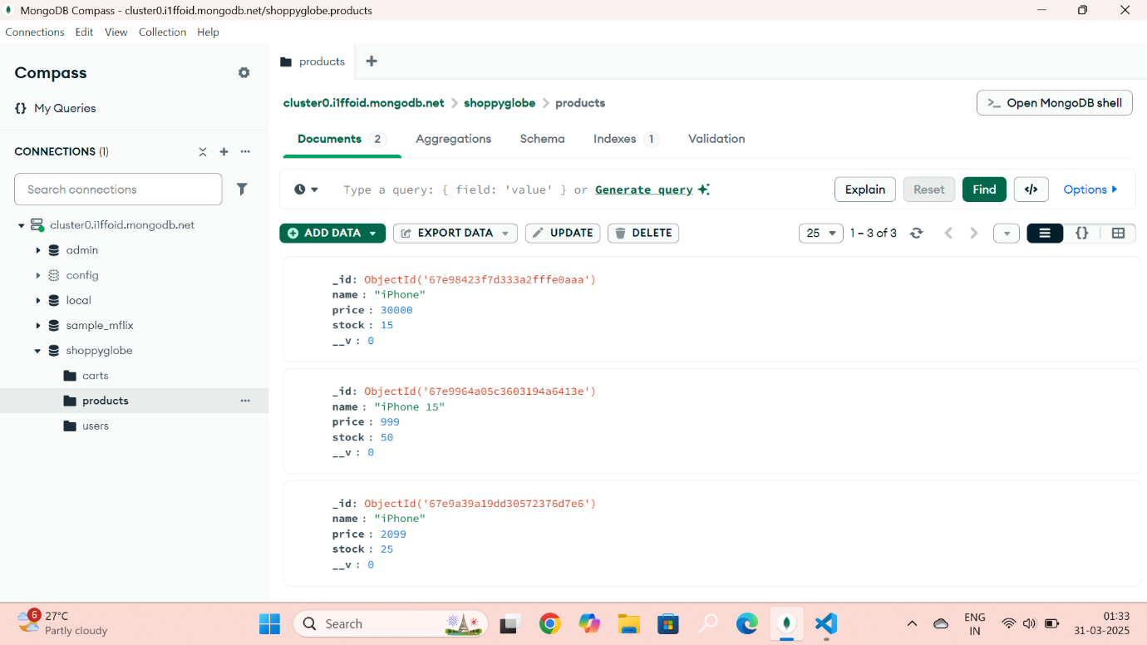

**2.GET /api/Products/:id** – Retrieves a **product** from the MongoDB database based on the provided id.

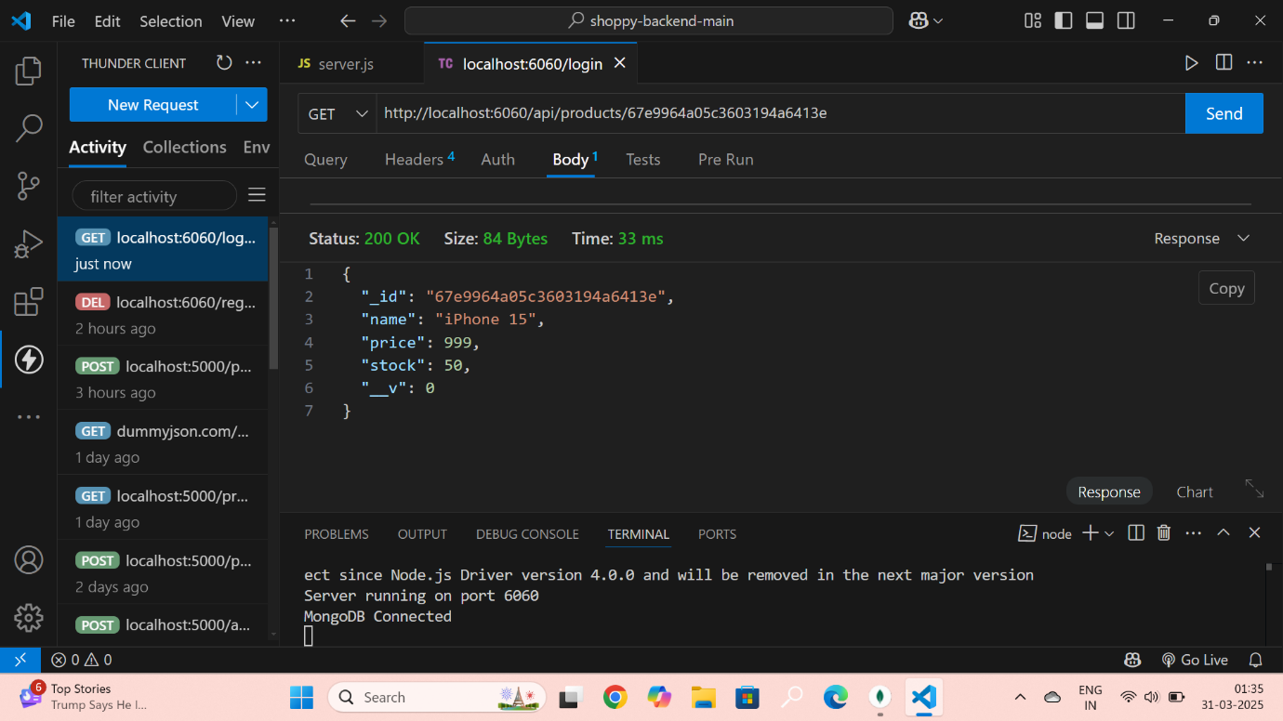

**3.PUT /api/Products/:id –UPDATE a product from the MongoDB database based on the provided id.**

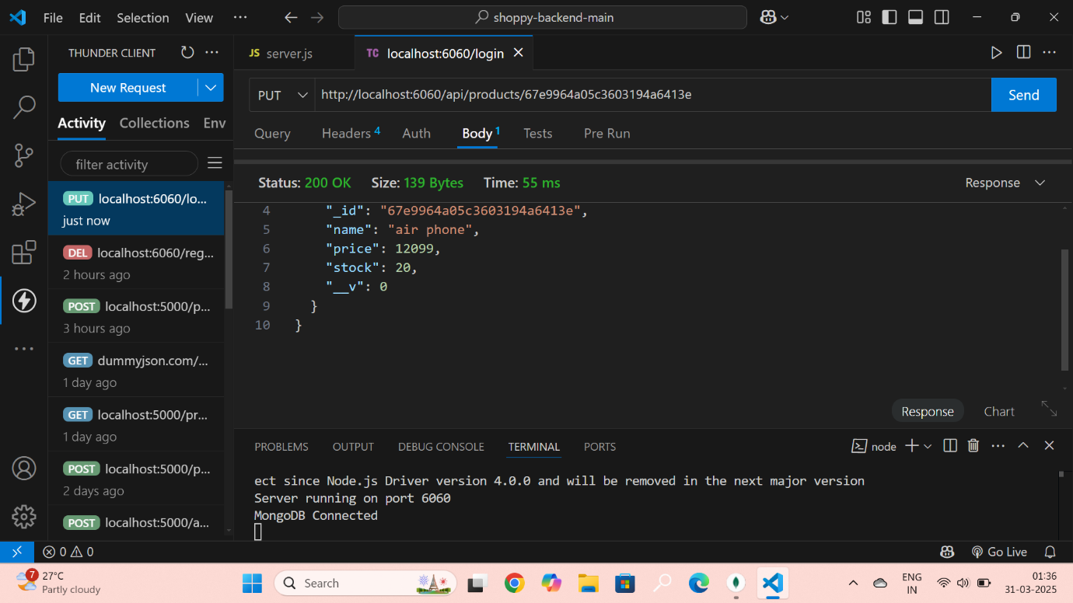

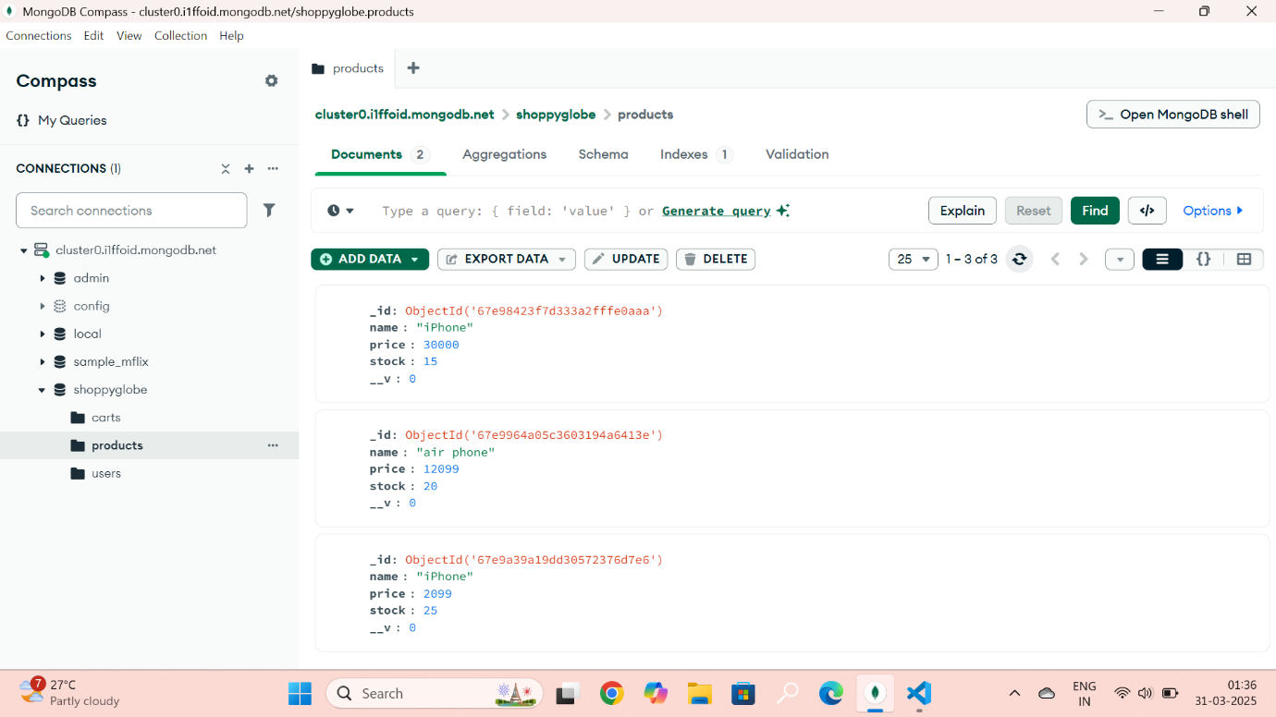

4.DELETE /api/Products/:id –DELETE a product from the MongoDB database based on the provided id.

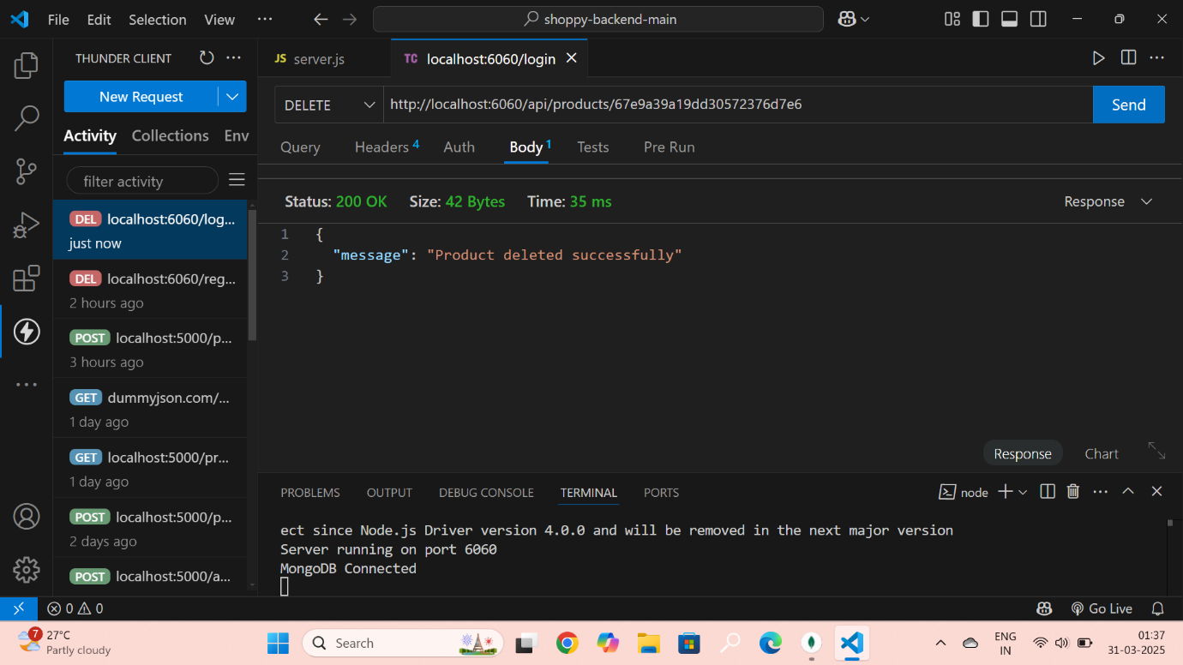

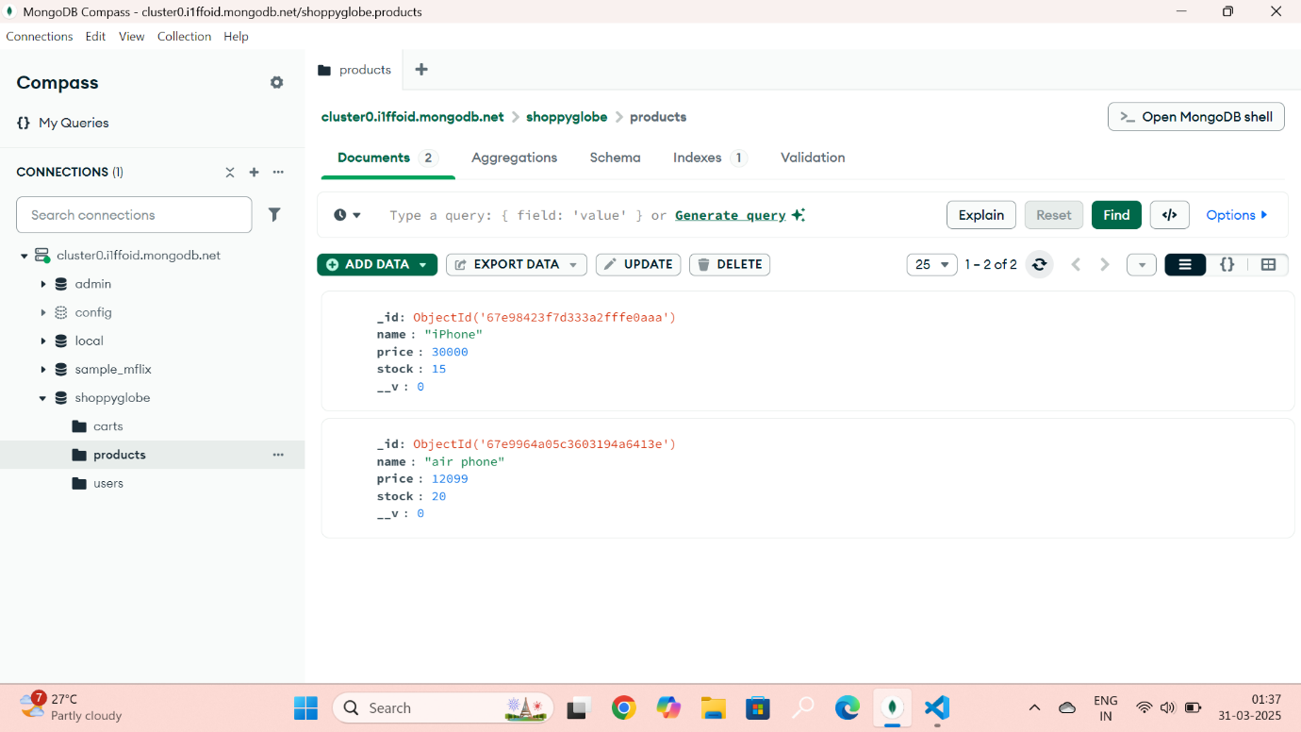

**POST /login – Validates user credentials and returns an authentication token if the credentials are correct.**

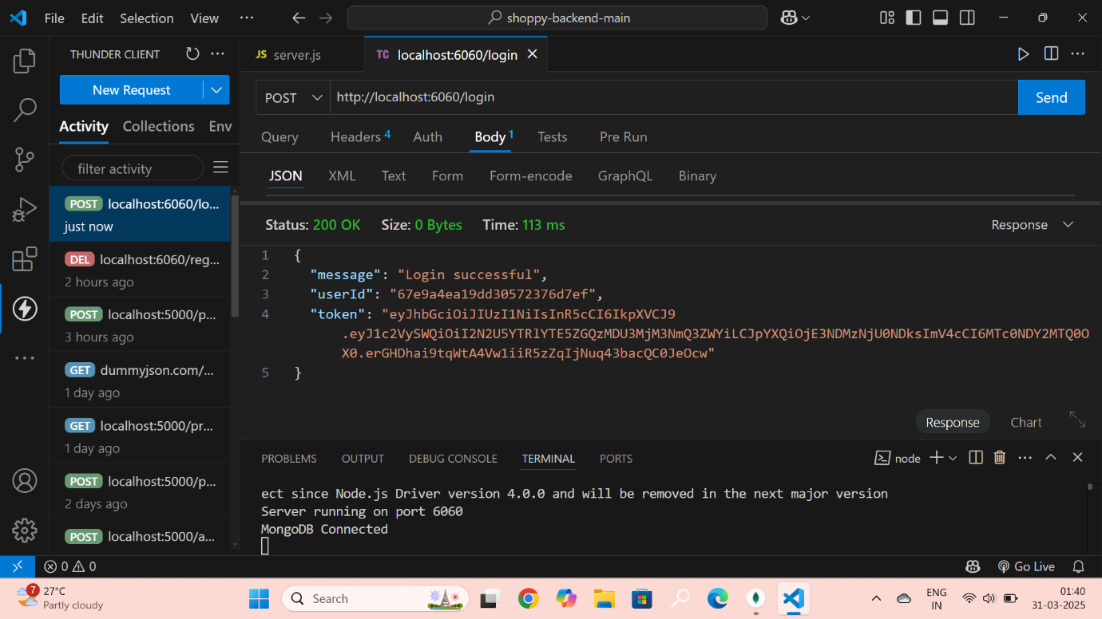

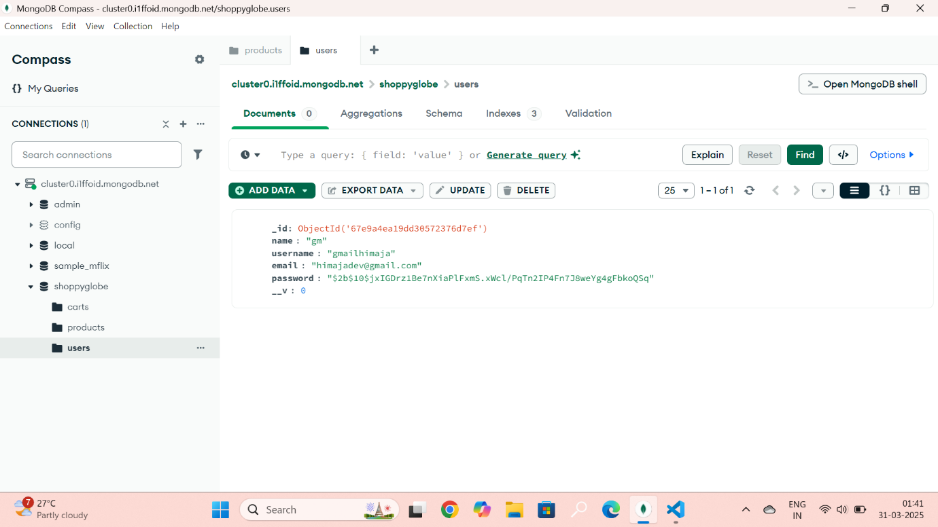

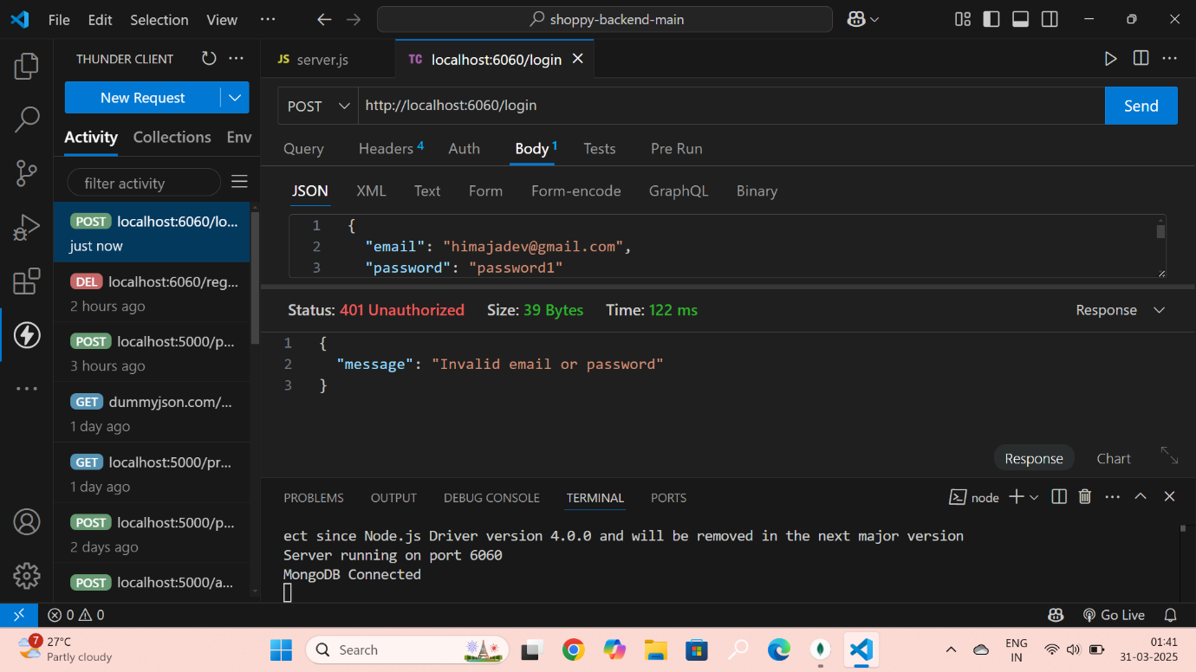

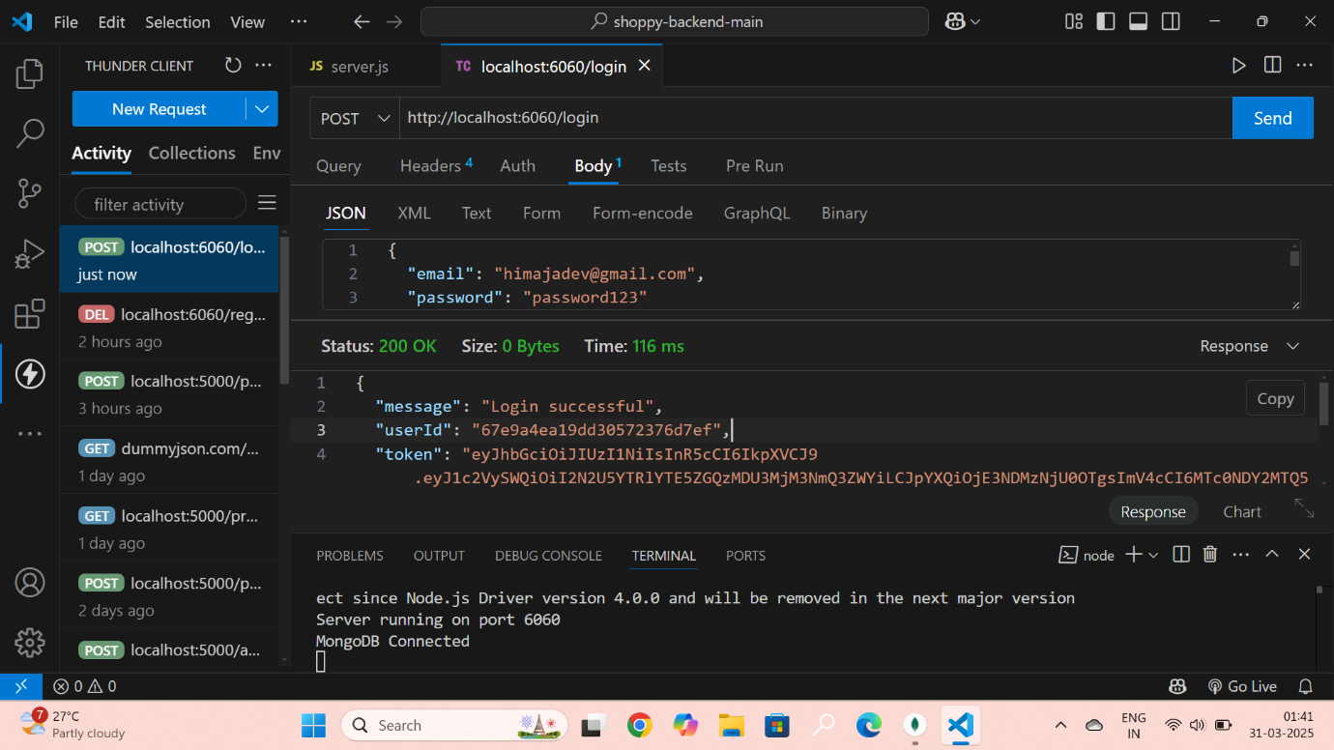

**1.POST /cart– Adds a new product to cart in the MongoDB database.**

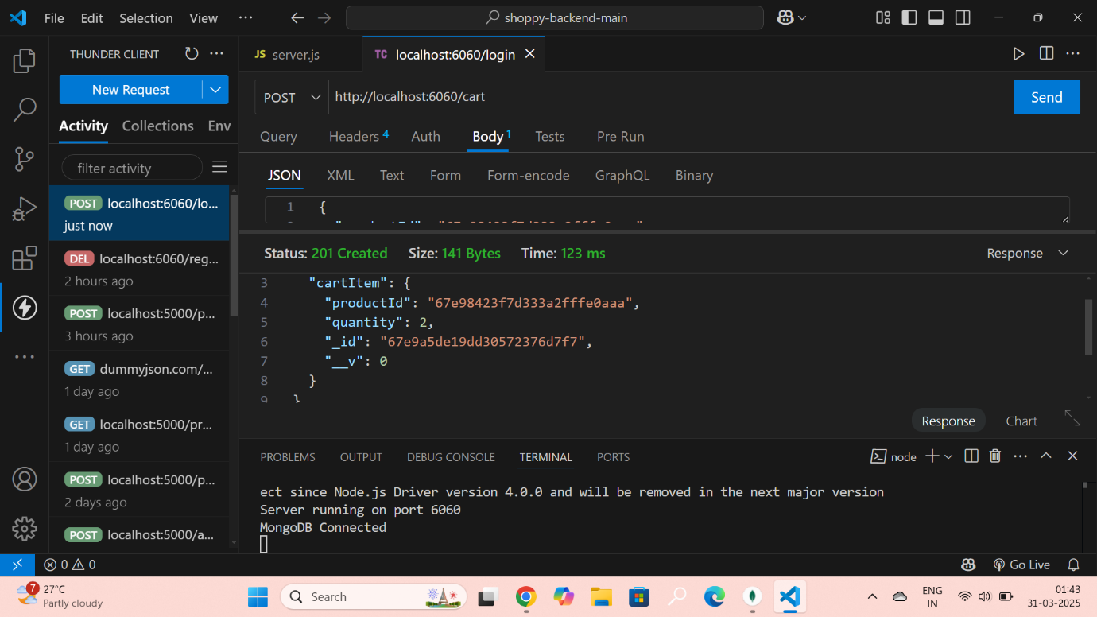

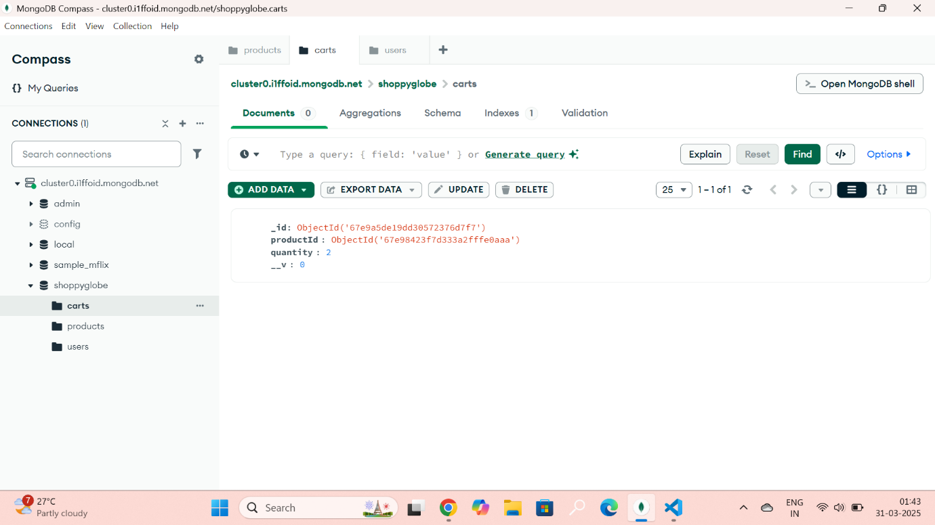

**2. PUT /cart/id – Updates an existing product in the cart in MongoDB database.**

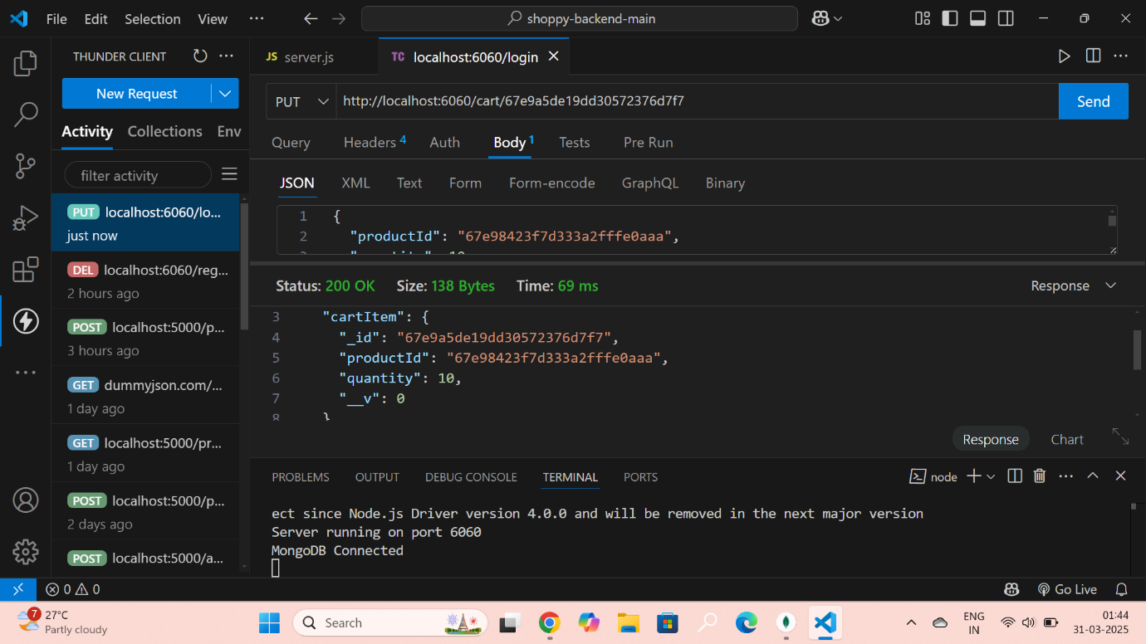

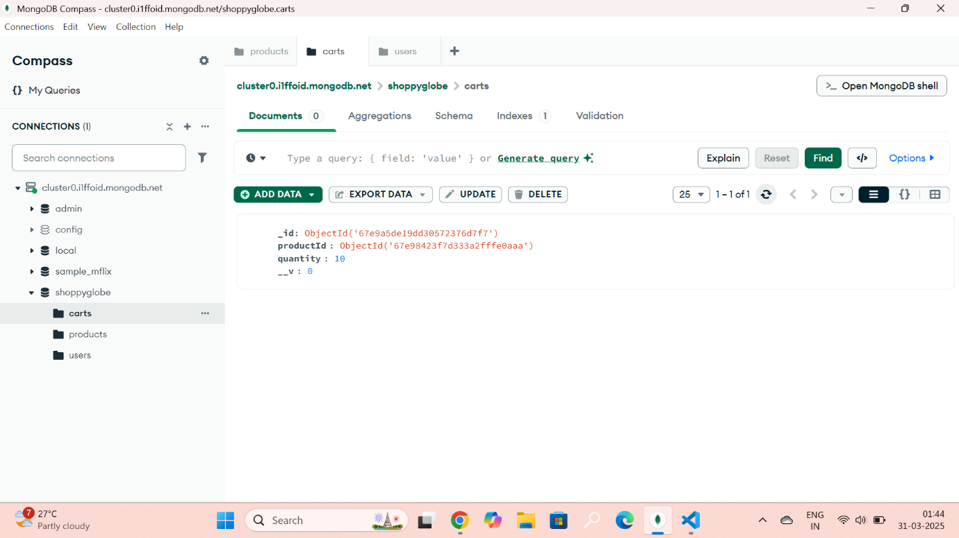

**3.Delete /cart/id – Delete an existing product in the cart in MongoDB database.**

